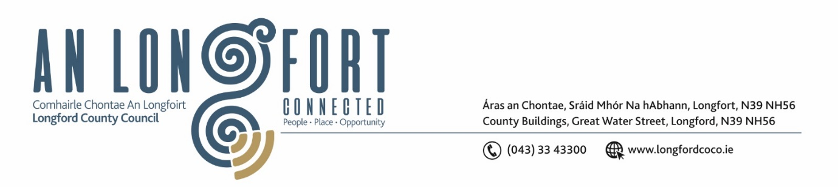

***Please note meeting will be held in the Council Chamber and via Microsoft Teams.***

6 Meán Fómhair 2023

**Chuig: Gach Ball don Chomhairle**

A Chomhairleoir,

Iarrtar ort bheith i láthair ag Cruinniú Míosuil Chomhairle Chontae Longfoirt a tionólfar i Seomra na Comhairle, Aras an Chontae, Longford agus via MS Teams are an **Chéadaoin 13ú Meán Fómhair 2023 ag 4pm** chun gnó a dhéanamh d’réir an Chláir thíos.

You are requested to attend the Monthly Meeting of Longford County Council to be held in the **Council Chamber and via Microsoft Teams** on **Wednesday 13 September 2023 at 4pm** to transact business, as set out on the Agenda hereunder.

Mise le meas,

**__________________**

***Claire McNabola***

***Meetings Administrator.***

**C L Á R**

Prayer before meeting.

1. Confirmation of Minutes:
2. Monthly meeting of Longford County Council held on 12 July 2023 – enclosed
3. Annual Meeting of Longford County Council held on 29 June 2023 - enclosed
4. Matters Arising.

**3.** Declaration of Interest by Members.

1. To note Management Report – to follow.

**5.** To note adopted Minutes of Corporate Policy Group Meeting held on the

13 June 2023 – enclosed

**6. Enterprise and Ukrainian Humanitarian Response**

1. Update on Ukrainian Response
2. Notice of Motions, submitted by Councillors, as listed hereunder

**Councillor Seamus Butler**

That the Ancient East Failte Ireland symbol be removed from the Cathedral Square and be replaced in all the Co Longford towns with a suitable Hidden Ireland symbol in all the towns in Co Longford.

**7. Finance and Information Technology**

1. To note adopted Minutes of meeting of Governance Strategic Policy Committee held on the 18 April 2023 – enclosed
2. Budgetary Process 2024
3. Local Authority Home Loans

**8. Housing, Planning, Regeneration & Capital Projects**

1. To note Planning Applications received since last meeting of the Council.
2. To note adopted Minutes of meeting of Climate Action and Planning Strategic Policy Committee held on the 17 April 2023 – enclosed
3. Notice of Motions, submitted by Councillors, as listed hereunder

**Councillor Seamus Butler**

That Longford County Council begin the process to revise the County Development Plan in light of the 2022 Census with a view to passing a motion to add housing Industrial zones before the end of 2023.

**9. Community, Library and Cultural Services, Corporate and Human Resources**

1. To note adopted Minutes of meeting of Placemaking Strategic Policy Committee held on the 21 February 2023 – enclosed
2. Consideration of Art’s strategy – “Art for Place, Art for People” – enclosed
3. Consideration of draft policy on visits by groups to the council - enclosed
4. Notice of Motions, submitted by Councillors, as listed hereunder

**Councillor Paul Ross**

I call on the Minister for Rural and Community Development to Engage with the Minister for Education to ensure Schools will be able to apply for CLÁR funded projects. This follows the decision by the schools insurance in the Ardagh/ Clonmacnoise Diocese that consent will not be given for future CLÁR projects that have the requirement that they are open to the public. This decision will mean that no school will be able to apply for CLÁR funding and a workable solution to the public liability insurance issue needs to be found as soon as possible.

**10. Infrastructure, Climate Action and Innovation**

1. To note adopted Minutes of meeting of Strategic Infrastructure Strategic Policy Committee held on the 17 April 2023 – enclosed
2. Notice of Motions, submitted by Councillors, as listed hereunder

**Councillor Mark Casey**

That Longford County Council suspend all paid parking in the County Town car parks until such time that the carparks/footpaths/signage/flower beds are cleaned up and made aesthetically appealing.

**Councillor Gerry Warnock**

I'm calling for the establishment of a standalone "Parks Division" within Longford County Council. This Division would have responsibility for the Upkeep and Maintenance of our public realm areas (including planters, memorial gardens), roundabouts, walkways, and other amenities. There should be crews within each of the Municipal Districts.

Over the last number of years Longford County Council has invested millions of euros of public money on the provision of aesthetically pleasing public realm works and recreational walkways that is certainly of benefit to the public and truly welcome. However, we are falling significantly short when it comes to the maintenance and upkeep of these works. The establishment of a Parks Division would remedy this and futureproof the capital investment for years to come.

**11. General**

1. Notice of Motions, submitted by Councillors, as listed hereunder

**Councillor Mark Casey**

I call on this Council to write to the Minister for Housing, Local Government and Heritage, Darragh O'Brien stating that Longford County Council fully supports the Fire Fighters in their current dispute and that the department should make the necessary adjustments to fulfil the basic demands of our Fire fighters.

**Councillor Paul Ross**

I call on The Minister for Agriculture, Food and the Marine Charlie McConalogue to reintroduce the Beef Finisher Payment Scheme to compensate beef farmers who have seen prices drop by almost €1/Kilo since May in an effort to save the struggling beef industry.

**Councillor Paraic Brady**

I call on Longford County Council to write to Minister for Agriculture, Food and the Marine to seek compensation for flooded landowners as weather has hampered farmers fodder collection.

**Councillor Garry Murtagh**

Calling on Longford County Council and its members to write to the Minister for Education Norma Foley to seriously review the school transport system and implement the necessary reforms to provide transport for all students living in rural areas.

**Councillor Uruemu Adejinmi**

I call on the Minister for Finance to extend the 9% VAT rate for food related hospitality businesses to the end of 2024 to help keep businesses in the sector open and prevent closure of low margin restaurants, cafes and food led pubs in County Longford and across Ireland.

**12. Correspondence**

1. Correspondence received on 14 August 2023 re. St. Joseph’s Care Centre Radiology Department - enclosed

**13. Votes of Sympathy**